Proposal Format:
- Proposal Title: Development of LCDS for Lung Cancer Classification, Detection, and Segmentation.
- Abstract: Lung cancer is one of the dangerous non-communicable diseases, which is caused the high death rate all over the world. According to WHO, lung cancer incidence is around 1,3 million deaths each year over the world. A previous epidemiological study that analyzed data from the Saudi cancer registry reported that the age standardized incidence rate of lung cancer in Saudi Arabia ranged from 1.2 to 12.3 per 100,000 cases in different regions of Saudi Arabia. In many cases, patients cannot survive because of improper prediction of disease and treatment at the late stage of the disease at the hospital. Also, the lack of continuous monitoring may reduce the survival rate. From this point of view, this project aims at developing a LCDS for lung cancer classification, detection, segmentation, and prognostics in different medical imaging modalities. In this proposal, a novel quantities biomarker / lung features will be investigated based on advanced image processing techniques to localize and predict the mass regions. Robust machine learning (ML), e.g., deep learning (DL), artificial intelligence (AI), GAN and XAI techniques will be developed to diagnosis the subtypes and stages of lung cancer. Also, lung cancer prognosis factor will be investigated to improve the personalized follow up of patient for specific period before and after the treatment. Different radiological images technologies, i.e., CT and MRI image, will be used for acquiring the data. The efficacy of all developed algorithm will be validated. Finally, a LCDS system will be developed with the framework and graphic interface for clinical practice and checked the quality of the LCDS model with different patients. The outcome of the proposed research might decrease the death rate by increasing the awareness of lung disease.
Keywords: Image processing, computer vision, GAN, XAI, medical imaging, detection, and
segmentation.

- Background and Motivation: Lung cancer is a major health problem in worldwide. Every year, approximately 1.3 million new lung cancer cases and about 1.2 million lung cancer deaths occur in Europe and North America. According to a statistic of World Health Rankings. A total of 473 part icipants were involved in this study. The majority of the study participants (74.6%) reported that they are current smokers. Almost 31.5% of the study participants reported that if lung cancer is detected early, the person’s chance of surviving is poor to very poor. The majority of the study participants reported that they would be willing to do tests to diagnose lung cancer if you were invited by the Ministry of Health or their doctor. Males, participants aged (24– 34 years), and current smokers were more likely to have positive attitude towards lung cancer screening (p ≤ 0.05). On the other hand, patients aged 46 years and over and those with higher education had less positive attitude towards lung cancer screening (p ≤ 0.05). Since lung cancer detection is hard in early stages, the majority of cases are most frequently diagnosed in the distant stage. Few lung cancer cases are diagnosed in the early stages when survival is better (i.e., an earlier diagnosis means better survival). Thus, a vast scope of lung cancer research is open for identifying lung disease in early stage and provide preventative treatment to achieve improved outcomes. Computer Aid Design (CAD) software has been playing a significant role in cancer detection for the past two decades. However, the usage of existing CAD for early detection of lung cancer has been unsatisfactory, because of its low sensitivity, low prediction accuracy, and high False Positive Rates (FPR). Therefore, LCDS proposes to extract new biomarker and features to improve the prediction efficiency and reduce the false positive rate. Many researchers investigated biomarker or features of lung cancer, i.e., shape features, such as eccentricity, circularity, and fractal dimension and textural features like mean, variance, entropy, correlation, skewness, and smoothness to train a classifier. However, the overall accuracy of those works is not up to mark. Counting its limitation, it does not classify the cancer effectively, which is future scope of this proposed research. Extract the advanced biomarker or select optimal biomarker may help to improve the efficacy of CAD software. In addition, different ML and AI models are investigated by researchers, i.e., decision tree, Naïve Bayes classifier, support vector machine and others. However, advanced ML algorithms like deep learning systems (e.g., CNN) have recently been introduced that can improve the classification rate. In addition, the optimization of kernel function may increase the performance of lung cancer LCDS software. The prognostics is a new era of research for monitoring the health condition of survivors before and after the treatment at the different stage of disease. As a part of prognosis, the continuous monitoring can provide better information for allowing effective treatment to the patient.

Resource constraints are a major barrier to lung cancer management, especially in ASIAN developing countries. The availability of data in these issues is very limited. Lung cancer cases are most frequently diagnosed in the distant stage, which means the cancer has spread to distant organs. So that the early-stage prediction is a challenging issue. Lung cancer screening is not recommended for everyone. There are some risks to lung cancer screening: i) A lung cancer screening test can have a false positive result, which can lead to further testing and unnecessary invasive procedures that may cause harm if the person does not have cancer. ii) There is some radiation risk. A low-dose CT scan uses about 15 times more radiation than a chest x-ray. However, a low dose CT scan uses five times less radiation than a conventional CT. Radiations produced from CT also increased the cancer risk.

The main objective of the project is to develop a Lung Cancer Detection System (LCDS) software for the prediction, diagnosis and prognostics of lung cancer before and after treatment, based on the analysis of radiological images in cancer patients. Together with the full clinical history of the cancer patients, the system will be capable to predict the probability of cancer relapse/ recovery after treatment, by continuous and personalized monitoring of each individual patient. In order to accomplish this, we will employ novel biomarkers that will allow the detection, classification and progression of lung cancer before and after treatment, and will provide insight of the probability of relapse in, e.g., the first five years after treatment. As such, four specific objectives are proposed:

1. The development of novel quantitative biomarkers / lung cancer features (i.e., statistical features, Texture features, geometric features, and Intensity based features.) for lung cancer detection and prediction using supervised and unsupervised machine learning techniques based on the analysis of radiological images (e.g., CT and MRI images).
2. Extraction of discriminant features of lung cancer or select optimal features for diagnosing the type or stage of lung cancer using different classical classification methods or deep learning models.
3. Find the effective prognosis factors and development of new data mining algorithms, approximate reasoning and artificial intelligence (AI) for modeling the probability of survival to personalized followup of lung cancer patient.
4. The prediction of the risk of relapse due to distant metastases for a specific period (e.g., the first five years) after diagnosis by searching for associations of the immune response, evaluated in standardized digital images and by using image analysis procedures.

- Literature Review: Medical imaging plays important roles to inform medical science and treatment. By evaluating the characteristics of human tissues, imaging is often used in clinical practice for oncologic diagnosis and treatment guidance [1], [2], [3]. The main goal of imaging is personalized medicine, where treatment is increasingly tailored on the basis of specific characteristics of the patient and their disease [4]. Personalized medicine has concerned on molecular characterization through genomic and proteomic technologies. However, as tumors are spatially and temporally heterogeneous, these techniques are limited. Thus, they require biopsies or invasive surgeries to extract and analyze what are generally small portions of tumor tissue, which do not allow for a complete characterization of the tumor. Imaging has great potential to guide therapy, since it can provide a more comprehensive view of the entire tumor and it can be used on an ongoing basis to monitor the development and progression of the disease or its response to therapy. Furthermore, imaging is noninvasive and is already often repeated during treatment in routine practice, on the contrary of genomics or proteomics, which are still challenging to implement into clinical routine. The most widely used imaging modality in oncology is X-ray computed tomography (CT), which assesses tissue density. Lung cancer is the number one cause of cancer deaths in both men and women in the worldwide. This growth can spread beyond the lung by the process of metastasis into nearby tissue or other parts of the body. Most cancers that start in the lung, known as primary lung cancers, are carcinomas. The two main types are small-cell lung carcinoma (SCLC) and non-small-cell lung carcinoma (NSCLC). About 58 percent of lung cancer cases occurred in less developed countries. The highest incidence of lung cancer was in Northern America and Europe, and the lowest incidence in Africa and Latin America. Indeed, CT images of lung cancer tumors exhibit strong contrast reflecting differences in the intensity of a tumor on the image, intra-tumor texture, tumor shape and geometric features as shown in Figure 1. The stages of lung cancer can be divided into five stages (i.e., stage I, II, III, IV and V) based on the riskiness of the cancer. Early stages of lung cancer have a better prognosis than later stages. Non–small cell lung cancer stages I or II generally have a more favorable prognosis than stages III, IV and V. Limited stage small cell lung cancers have a much better prognosis than extensive stage cancers. In clinical practice, tumor response to therapy can be measured using one- or two-dimensional descriptors of tumor size (RECIST, WHO) [5]. Although a change in tumor size can indicate response to therapy, it often does not predict overall or progression free survival [6],[7]. Some works have characterized the appearance of a tumor on CT images, these characteristics are typically described subjectively and qualitatively (moderate heterogeneity, highly speculated and large necrotic core). However, recent advances in image acquisition, standardization and image analysis allow for objective and precise quantitative imaging descriptors that could potentially be used as noninvasive prognostic or predictive biomarkers [16]. A field of medical study aims to extract large number of quantitative features from CT medical images using data-characterization algorithms that features [8], [9], called radiomic features. Radiomics converts imaging data into a high dimensional mine-able feature space as shown in Figure 1. In addition, they capture distinct phenotypic differences of tumors and have prognostic power and thus clinical significance across different diseases. Radiomics emerged from the medical field of oncology [10] and is the most advanced in applications within that field. However, the technique can be applied to any medical study where a disease or a condition can be tomographically imaged. In addition, in [16], different features have been extracted from the tumor region: texture, geometric features, such as volume, rectangular Fit and compactness, intensity-based features like mean brightness measure in terms of Hounsfield units (HU). The combination of these features has fed to a classifier (e.g., SVM) for tumor classification. Many works have explored different genomic biomarkers to identify different genomic defects in lung cancer development and prognosis. In [17], two biomarkers, namely excision repair cross-complementing 1 (ERCC1) gene product and the regulatory subunit of rib nucleotide reeducates (RRM1), have been used as prognostic biomarkers of the stage I patients. They also proposed a LCDS detection approach to segment malignant tumors depicting on CT images acquired before surgery and compute tumor-related morphological, density, and texture-based image features. They then trained a Naive Bayesian network-based classifier to predict the risk of the cancer. Furthermore, a radionics signature to estimate the disease-free survival (DFS) in patients with early-stage (I–II) have been proposed in [19]. These radionics features have been used as an independent biomarker performed by using multivariate Cox regression (i.e., the effect of radionics features extracted upon the cancer classification) and least absolute shrinkage and selection operator. Recently, with the widespread of using deep learning systems, such as Convolutional Neural Networks (CNNs), researchers have used such models as end-end machine learning algorithms to automatically learn features from raw images directly and to properly represent images at different scales and orientations better than traditional image processing techniques for detecting radionics features [20]. In [21], CNN have been proposed to increase the sensitivity and accuracy of the classification of potential lung nodules. In turn, two deep segmentation models based on CNN have been proposed: one is based on morphology and statistic of size of the image area to eliminate the influence of the trachea to pulmonary parenchyma image segmentation, in addition the second is for region of interest (ROI) extraction based on morphology and circular filter. Moreover, in order to detect nodules from a CT scan, the authors of [22] have implemented three stages scheme. Firstly they have used extract the lungs from the entire volume using a mask previously calculated for each patient. They have then performed a candidate generation using morphological operations. Finally, they have used the extracted candidates to train a 3D CNN for nodule classification and false positive reduction.

- Aims and Objectives: Digital imaging has changed the landscape of diagnostic medicine in the last years, especially concerning the detection and analysis of lung cancer. Digital radiology is already established as the default technique for detection of cancer. However, the researcher aims to develop more robust techniques based on image processing and artificial intelligence. Tumor detection and classification results are highly dependent on the quality of the digital imaging. And this point is critical – a bad detection can yield a bad diagnosis. As such, much work still needs to improve the techniques of detection and classification. Thus, our technique aims to be quite clear: the ability to analyze different modalities of digital imaging through an image analysis software that can benefit from all advances in computer science (image processing, machine learning, artificial intelligence, etc.) to create a tool for truly personalized medicine. Image analysis can support cancer detection, its treatment and prediction of relapse of cancer for each patient. In order to accomplish this, we are joining teams that are experts in computer sciences, biomedical engineers, digital radiology and lung cancer (academic and non-academic), and leverage their knowledge to develop a robust predictor system that can be used by medical staff to provide a better service and quality of life for their cancer patients. In particular, we are targeting innovations in:
- Development of novel radiology-image biomarkers from the tumor using CT and MRI images.
- Improvement of the quality of CT images-based image analysis techniques.
- Development of novel biomarkers from radiology images for the classification of lung cancer subtypes.
- Development of novel biomarkers from radiology images for the prediction of cancer relapse.
- Development of a prediction model for distant metastasis relapse that includes radiologic-biomarkers and the clinical data from the patients.
- Integration of all proposed techniques in a LCDS model that will be available in as standard web platform that can be used by doctors all over the world for the personalized assistance of their lung cancer patients.

- Research Plan and Methodology
From the radiology point of view, this project will follow the four phases methodology described below:

- Apply preprocessing for enhancing and localizing the lung cancer: The first phase consists of the employment of advanced image processing techniques for preprocessing the image data acquired from affiliated hospital. The preprocessing may include:
- Noise reduction for enhancing the quality of image.
- Constricting the 2D or 3D models for segmentation of lung and tumor of lung.
- Color space customization if needed.

- Prediction of lung cancer using biomarker: The second phase consists of the development of biomarkers for the precise identification of the cancer from the analysis of 2D/3D digital images, particularly in CT and MRI images through the following steps:
- Different lung cancer features (i.e., statistical features, Texture features, geometric features, and Intensity based features) for quantifying the existence of lung cancer.
- Different Deep learning techniques (i.e., CNN, Deep Learning) to detect the tumor segmentation.
- Different clustering techniques will apply by extracting features to detect the abnormalities of lung.

- Diagnosis of types / stage of lung cancer: This phase consists of the diagnosis of patient based on the acquired data in order to detect more normal or aggressive lung cancer types by
- Obtaining characteristics of the tumor regions segmented in the previous step will be calculated by feature extractors to map to the classification and deep learning model e.g., Convolutional Neural Network CNN [13], [14], [15].
- Classifying of tumor types based on a multinomial classification method based on decision Tree, support vector machines (SVM) or deep models CNN. As soon as the cancer type is known, we proceed to the next phase, where a personalize treatment is proposed, and the same visual biomarkers are used to provide continuous monitoring of the affected tissue after the treatment, in order to detect if the cancer is still present [14], [15].

- Development of prognostics model for analysis the development of cancer: In this phase, the prognostics features will be used for the continuous extraction of information from digital images of patient follow-up. To do this,
- The evolution of the temporal analysis of cancer regions from the data provided by these biomarkers, considering images of different modalities (especially CT and MRI) will be quantified.
- The regression model will be used for measuring the probability of survival of lung cancer.
- The detection of local recurrence (relapse probability) by the perceived quantitative changes in lung cancer regions after applying different radiotherapy and treatment.

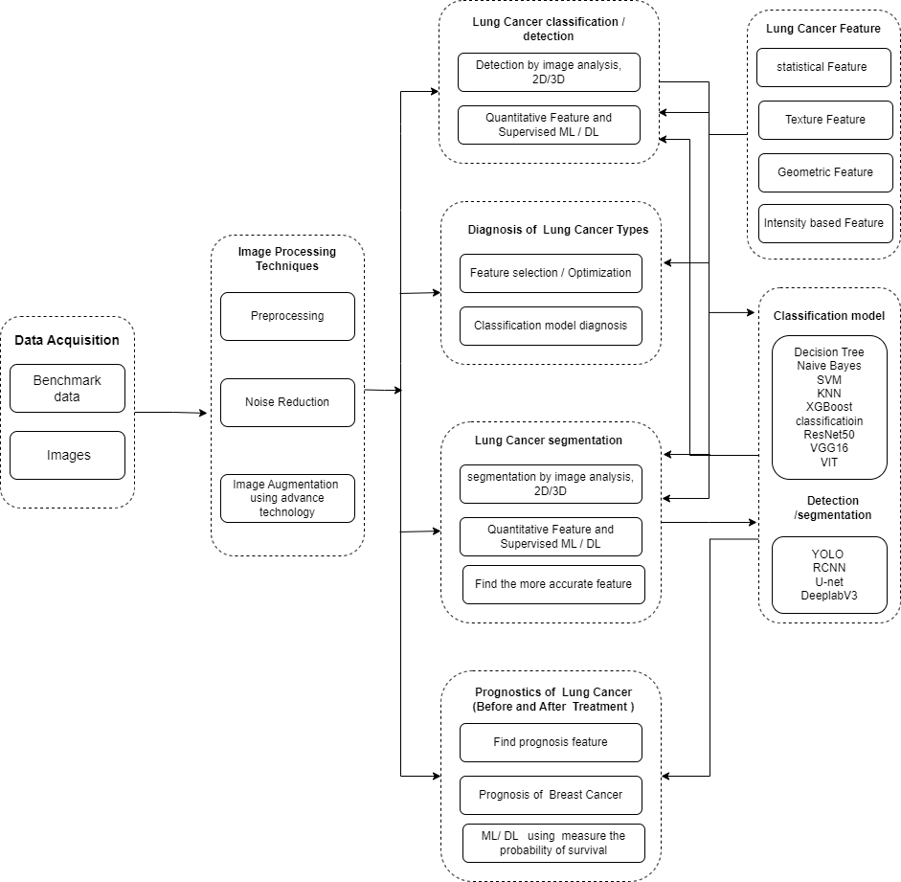
Figure 1: Overall flow of methodologies of proposed research.

- Conclusions: The study on the economic burden of lung cancer estimates that the overall costs, from diagnosis to a maximum of two years thereafter, to be about $46,000. The main cost drivers were hospitalization (49% of costs) and outpatient office visits (35.2% of costs), with a monthly initial treatment phase cost of $11,500 per patient. Thus, the better diagnostic yields better treatment, which subsequently reduces the economic cost. For this reason, and for the first time, we are proposing joining the two sources of radiological imaging about lung cancer: CT and MRI. A LCDS software that on the basis of two information will be developed tool predict the probability of relapse for distant metastasis after treatment. It will do using complete clinical history data of the patient and results of analysis of two types of cancer imaging modalities: radiology images of lung.

8. References
[1] Kurland, B. F. et al. Promise and pitfalls of quantitative imaging in oncology clinical trials. Magn. Reson. Imaging 30, 1301–1312 (2012).
[2] Buckler, A. J., Bresolin, L., Dunnick, N. R. & Sullivan, D. C. Group. A collaborative enterprise for multistakeholder participation in the advancement of quantitative imaging. Radiology 258, 906–914 (2011).
[3] Buckler, A. J. et al. Quantitative imaging test approval and biomarker qualification: interrelated but distinct activities. Radiology 259, 875–884 (2011).
[4] Lambin, P. et al. Predicting outcomes in radiation oncology—multifactorial decision support systems. Nat. Rev. Clin. Oncol. 10, 27–40 (2013).
[5] Jaffe, C. C. Measures of response: RECIST, WHO, and new alternatives. J. Clin. Oncol. 24, 3245– 3251 (2006).
[6] Burton, A. RECIST: right time to renovate? Lancet Oncol. 8, 464–465 (2007).
[7] Birchard, K. R., Hoang, J. K., Herndon, J. E. & Patz, E. F. Early changes in tumor size in patients treated for advanced stage nonsmall cell lung cancer do not correlate with survival. Cancer 115, 581–586 (2009).
[8] Lambin, P. et al. Radiomics: extracting more information from medical images using advanced feature analysis. Eur. J. Cancer 48, 441–446 (2012).
[9] Kumar, V. et al. Radiomics: the process and the challenges. Magn. Reson. Imaging 30, 1234–1248 (2012).
[10] Gillies, Robert J.; Kinahan, Paul E.; Hricak, Hedvig (2015)."Radiomics: Images Are More than Pictures, They Are Data". Radiology. 278(2): 563–577. 14 of 24 CONFIDENTIAL AMED-AEI JOINT CALL FOR PROPOSALS
[11] Long, J., Shelhamer, E., & Darrell, T. (2015). Fully convolutional networks for semantic segmentation. In Proceedings of the IEEE conference on computer vision and pattern recognition (pp. 3431-3440).
[12] Ronneberger, O., Fischer, P., & Brox, T. (2015). U-net: Convolutional networks for biomedical image segmentation. In International Conference on Medical image computing and computer-assisted intervention (pp. 234-241). Springer, Cham.
[13] Talukdar, J., & Sarma, P. (2018). A Survey on Lung Cancer Detection in CT scans Images Using Image Processing Techniques. International Journal of Current Trends in Science and Technology, 8(03), 20181-20186.
[14] Alakwaa, W., Nassef, M., & Badr, A. (2017). Lung Cancer Detection and Classification with 3D Convolutional Neural Network (3D-CNN). Lung Cancer, 8(8).
[15] Kirienko, M., Sollini, M., Silvestri, G., Mognetti, S., Voulaz, E., Antunovic, L., & Chiti, A. (2018). Convolutional Neural Networks Detect Local Infiltration of Lung Cancer Primary Lesions on Baseline FDG-PET/CT.
[16] A. Vial e.t al., "Assessing the prognostic impact of 3D CT image tumour rind texture features on lung cancer survival modelling,"2017 IEEE Global Conference on Signal and Information Processing (GlobalSIP), Montreal, QC, 2017, pp. 735-739.
[17] S. H. Hawkins et. al., "Predicting Outcomes of Nonsmall Cell Lung Cancer Using CT Image Features," in IEEE Access, vol. 2, pp. 1418-1426, 2014.
[18] S. Basub et. al., "Developing a classifier model for lung tumors in CT-scan images," 2011 IEEE International Conference on Systems, Man, and Cybernetics, Anchorage, AK, 2011, pp. 1306-1312.
[19] N. Emaminejad et. al., "Fusion of Quantitative Image and Genomic Biomarkers to Improve Prognosis Assessment of Early Stage Lung Cancer Patients," in IEEE Transactions on Biomedical Engineering, vol. 63, no. 5, pp. 1034-1043, May 2016.
[20] Huang, Y., Liu, Z., He, L., Chen, X., Pan, D., Ma, Z., & Liang, C. Radiomics signature: A potential biomarker for the prediction of disease-free survival in early-stage (i or ii) non—small cell lung cancer. Radiology, 281(3), 947-957, 2016.
[21] Krizhevsky, A., Sutskever, I., Hinton, G.: ImageNet Classification with Deep Convolutional Neural Networks. Version. In: Pereira, F.; Burges, Bottou, L.; Weinberger, K. Q. (Hrsg.): Advances in Neural Information Processing Systems 25. Curran Associates, Inc., 2012, 1097–1105.
[22] Jin, Xin-Yu, Yu-Chen Zhang, and Qi-Liang Jin. "Pulmonary Nodule Detection Based on CT Images Using Convolution Neural Network." In Computational Intelligence and Design (ISCID), 2016 9th International Symposium on, vol. 1, pp. 202-204. IEEE, 2016.

